Before we get started:

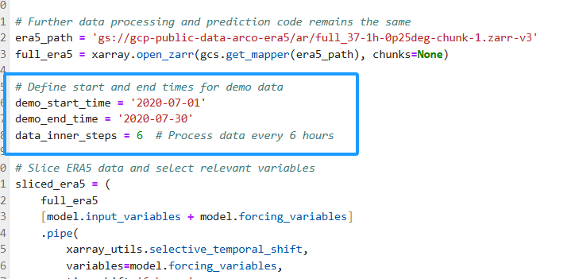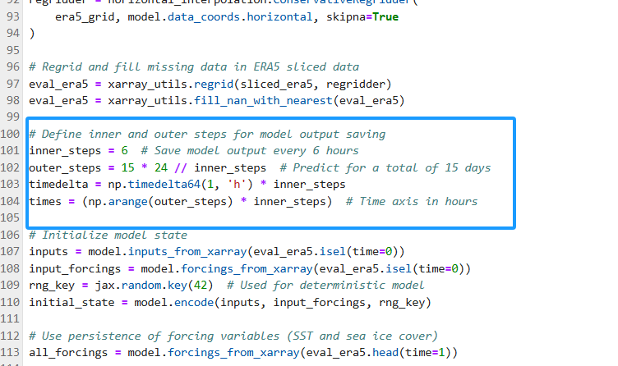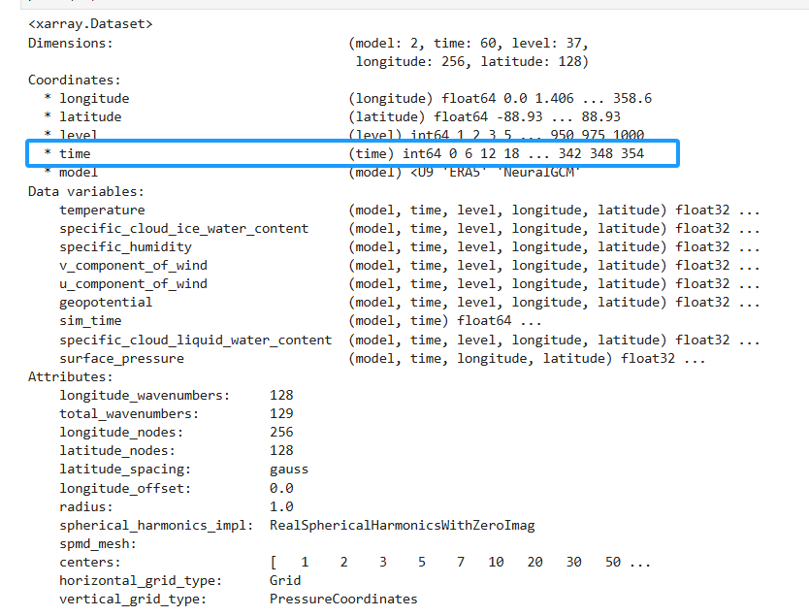

This week, we focused on two main issues. The first issue involves modifying the NeuralGCM model code to achieve a "cut" effect on the data：

We initially used the NeuralGCM official example code from the

https://neuralgcm.readthedocs.io/en/latest/inference_demo.html. The main objectives of this code were:

Please see the **original.py**

While running the modified code, we encountered several errors. Below are the attempts made, the errors encountered, and the analysis.

1. First Error: Variable Name Mismatch

```

ValueError: expected variable geopotential not found

```

**Reason of leading this problem:**

①Variable Renaming Issue: The model expects to find a variable named `geopotential` in the dataset, but it might not exist in the dataset, or the variable name might have been changed.

②Inconsistent Variable Naming: During data loading or renaming, the variable names might not align with the model's expectations, causing the model to be unable to locate the required variable.

**Attempted Solutions:**

①Check Variable Names: Ensure that the dataset contains all variables expected by the model.

②Maintain Consistent Variable Names: Avoid unnecessary renaming of variables or correctly rename variables to match the model's expected names.

2. Second Error: Variable `temperature` Not Found

```

ValueError: expected variable temperature not found

```

**Reason of leading this problem:**

①Incorrect Variable Renaming: We might have renamed the `temperature` variable to `t`, causing the model to be unable to find the `temperature` variable.

②Inconsistent Variable Naming with Model Expectations: The model expects the variable to be named `temperature`, but the dataset uses `t`.

**Attempted Solutions:**

①Do Not Rename `temperature`: Keep the variable name as `temperature` to match the model's expectation.

②Update Unit Mapping and Input Variable Lists: Ensure that `new_inputs_to_units_mapping` and `new_input_variables` use `temperature` instead of `t`.

3. Third Error: Variable `u_component_of_wind` Not Found

```

ValueError: expected variable u_component_of_wind not found

```

**Reason of leading this problem:**

①Inconsistent Variable Naming:The model expects the variable to be named `u_component_of_wind`, but the dataset might be using `u` or another name.

②Incorrect Variable Renaming: The variable might not have been correctly renamed or kept its original name during data loading and processing.

**Attempted Solutions:**

①Determine Model's Expected Variable Names:Print `model._input_variables` to get the model's expected variable names.

②Ensure Dataset Variable Names Align with Model Expectations: After data loading, do not rename variables unnecessarily or correctly rename variables to match the model's expected names.

4. Fourth Error: `TypeError: Invalid magnitude for Quantity: None`

```

TypeError: Invalid magnitude for Quantity: None

```

**Reason of leading this problem:**

①Missing Unit Mapping:The `inputs_to_units_mapping` might be missing units for some variables, causing the units to be `None` during dimensional assignment.

②Variable Value is `None`:Some variables in `inputs` or `inputs_to_units_mapping` might have `None` values.

③Version Compatibility Issues:The version of `pint` or other libraries might lead to incompatible behavior.

**Attempted Solutions:**

①Ensure All Variables Have Correct Unit Mappings: Add all model-expected variables and their units in `new_inputs_to_units_mapping`.

②Check All Variable Values: Before initializing the model state, print `inputs` and `input_forcings` to ensure no variables have `None` values.

③Verify Model Configuration and Variable Naming Consistency Ensure that the variable names in the model configuration match those in the dataset.

5. Fifth Error: Variable `geopotential` Not Found

```

ValueError: expected variable geopotential not found

```

**Reason of leading this problem:**

①Inconsistent Variable Naming: The model expects the variable to be named `geopotential`, but the dataset might be using `z` or another name.

②Incorrect Variable Renaming: The variable might not have been correctly renamed or kept its original name during data loading and processing.

**Attempted Solutions:**

①Maintain Consistent Variable Naming: Ensure that the variable names in the dataset match exactly what the model expects.

②Avoid Unnecessary Variable Renaming: Do not rename variables after data loading unless necessary and aligned with model expectations.

1. KeyError: 'sea_ice_cover'

Possible problems:

1. Consistency in Variable Names and Units: The model has strict requirements for input variable names and their corresponding units. Any inconsistency can prevent the model from running correctly.

2. Completeness of the Dataset: Ensure that the dataset contains all variables required by the model and that these variables are complete, without missing values or `None` values.

3. Caution When Renaming or Deleting Variables: Avoid renaming or deleting variables unnecessarily during data processing unless certain that such actions will not affect the model's operation.

We can see the **try_download_desired_variable.py**

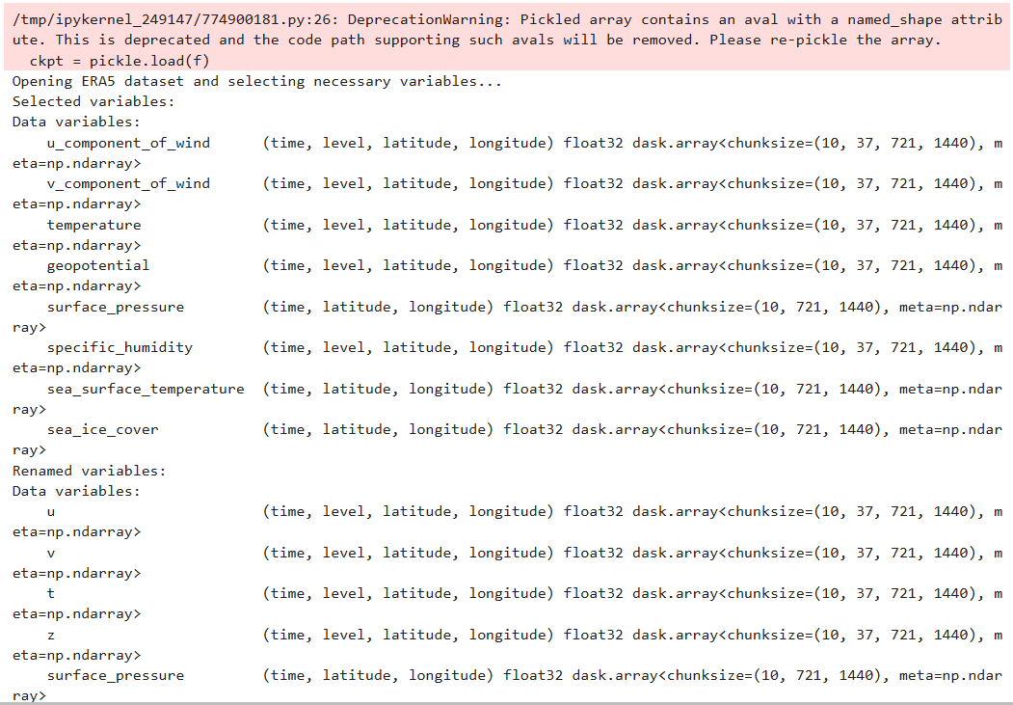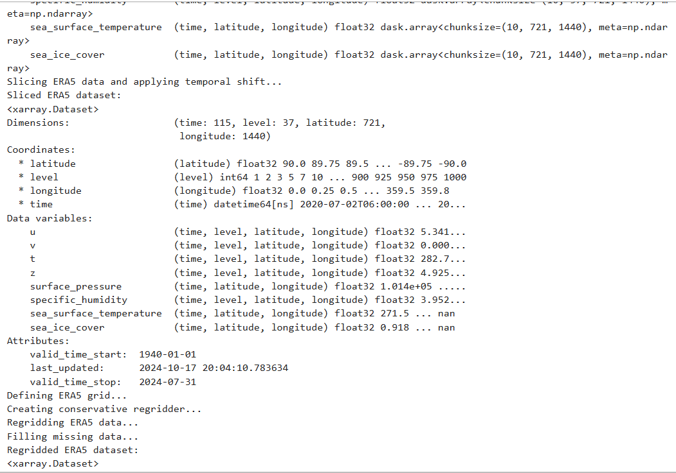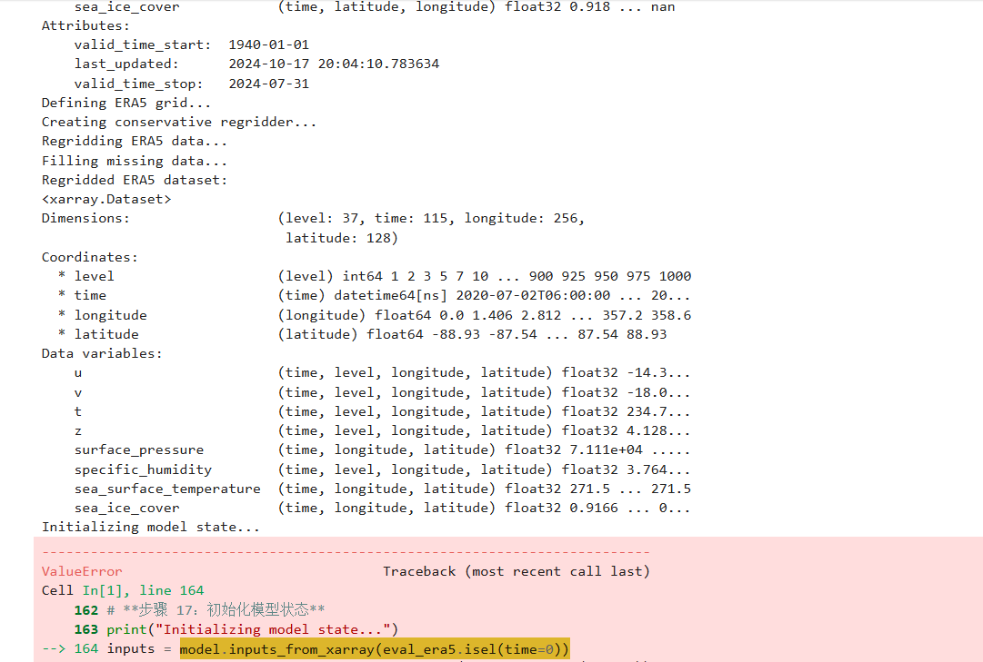

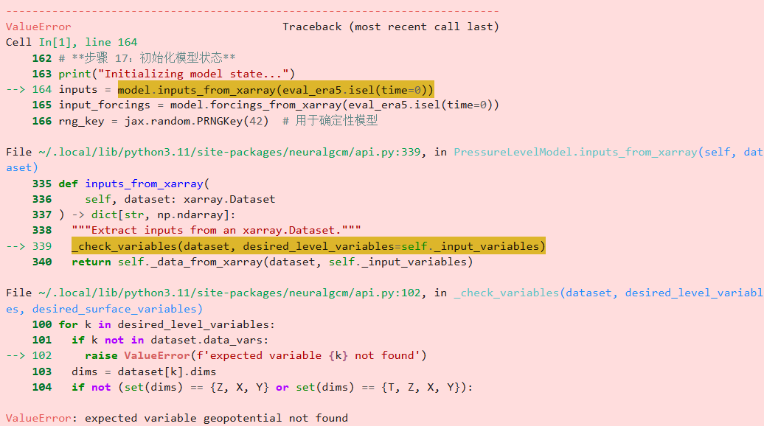

The second issue was adjusting the output data from the NeuralGCM model to ensure compatibility with the TempestExtremes (TE) model，including adjust U_component_of_wind to U10M, V_component_of_wind to V10M. We also changed the format of time, from 0 to 2020-07-01T00:00:00.000000000.

Please see **Cut_obtained_dataset.py**

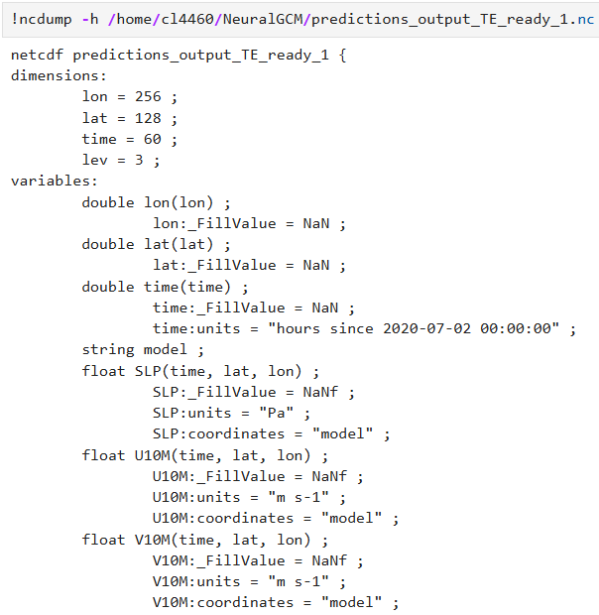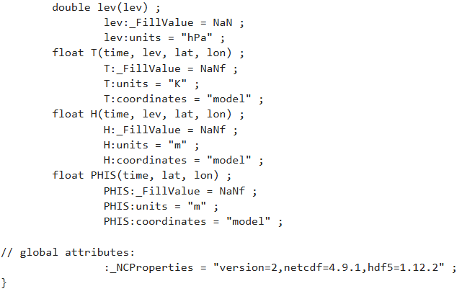

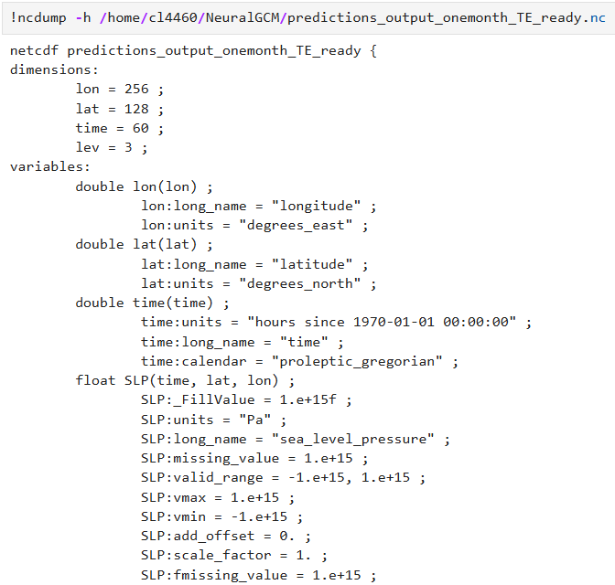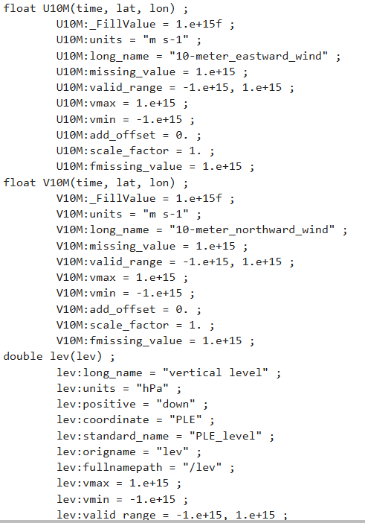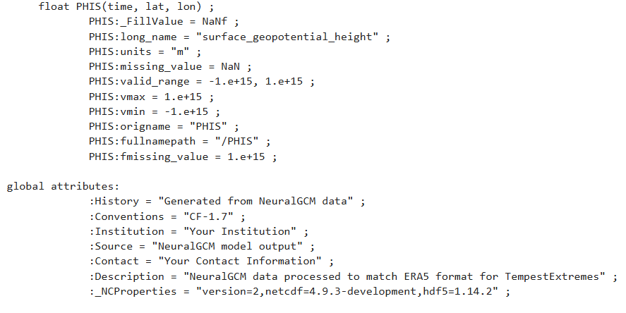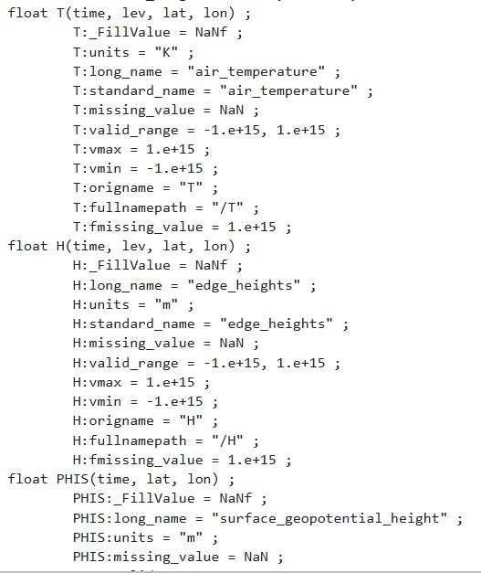

We processed 15-day prediction data with initial values on 07/01, 07/02, and 07/03, respectively, and generated corresponding storm trajectory plots for each.

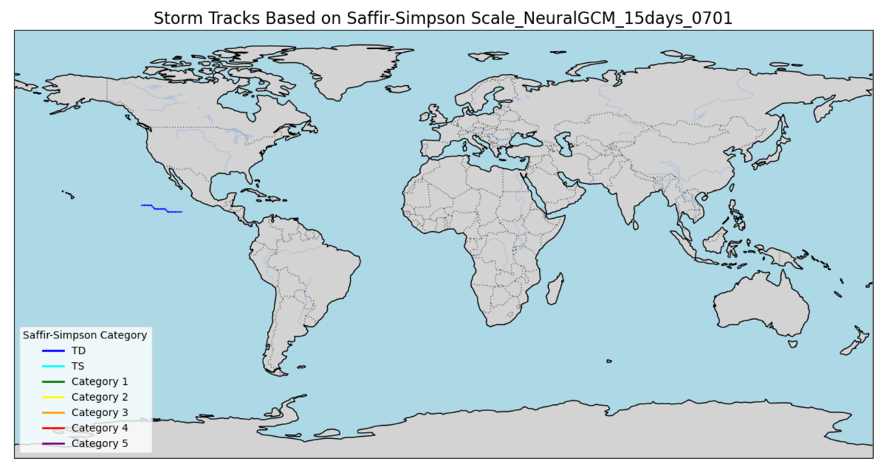

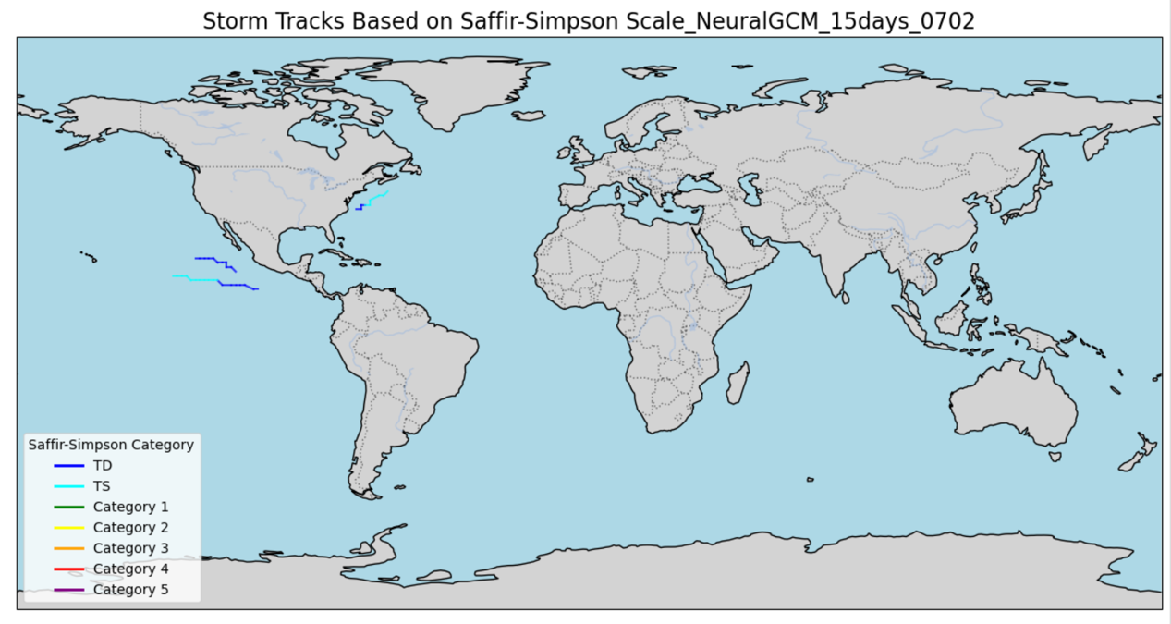

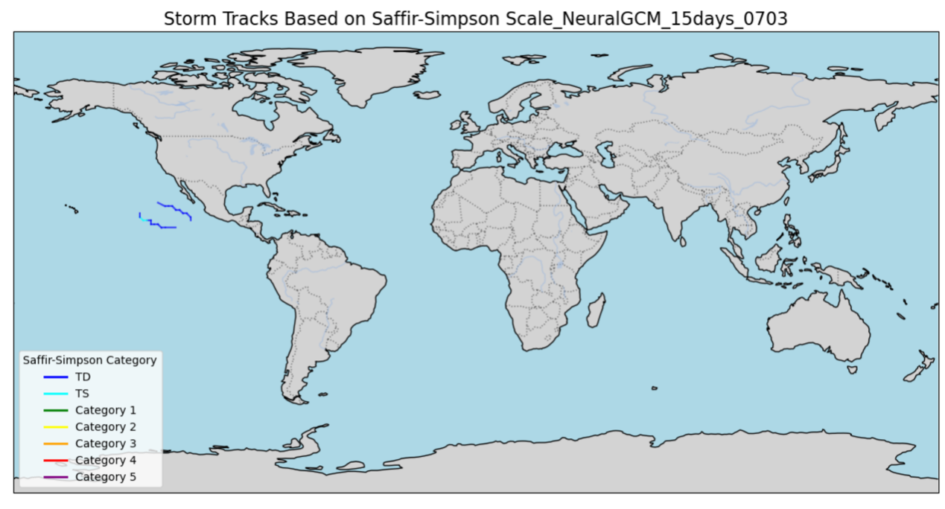

However, when attempting to run the TE model with three input files simultaneously, the script encountered an error, which prevented successful execution.



